Date | Version | Description | Prepared by | Approved by
 | 1.0 | Report to Fetch Long Text only from Notification and Work Orders | B Balakrushna  Naveen B

Client name | United Spirits India Ltd
Project name | SAP PM Implementation
Module | Plant Maintenance
Document number
Version | 1.0
Date
Type of development | Enhancement/ Workflow
Complexity | Medium
Reusable | yes

Document revision history

Table of content
1.0 Overview and Scope 2
1.1 References 2
1.2 Functional Description 3
1.3 Dependencies / Constraints 3
1.4 Assumptions 3
1.5 Initiating process 3
1.6 Frequency and Timing 3
1.7 Processing Type 3
2.0 Detailed Functional Requirements 3
2.1 Functional Specification 3
2.2 Processing description 4
2.2.1 Step 1 4
2.3 Parameters and configuration 4
2.4 Messages 4
2.5 Security and Authorization 4
2.6 Existing Sample Enhancements 4
2.7 Processing and Operational Considerations 4
2.7.1 Performance 4
2.7.2 Batch Requirements 4
2.7.3 Other 4
2.8 Change Management Requirements 4
3.0 Testing Requirements 5
3.1 Key Business Test Conditions 5
3.2 Technical Test Conditions 5
3.3 Risk and Controls Test Conditions 5
3.4 Testing Considerations/Dependencies 5
4.0 Additional supporting / reference documentation 5
5.0 Outstanding Issues 5
6.0 Data Impacts 5

Overview and Scope
In USL Maintenance team has a requirement to develop Long Text only report for a Notification and Work Order. By running this report user is able to get the Notification/WO and corresponding Long Text maintained against it.

References

Type | Reference | Name
Development Request
Development ID
Technical Specification

Functional Description

In the process of creating a Notification and Work Order from SAP application user can maintain short description and Long description. In short description field user briefly mentions the reason and relevant information for creating a Notification or Work Order. Here, user has a 40 character limitation.

If the user has to maintain more information in text for a Notification/Work Order SAP has provided a feature to document it in Long Text. By clicking on the Long text icon in the WO or Notification header user is navigated to a platform where he/she can maintain the relevant Text. Here there is not character limitation.

In USL Maintenance team has a requirement to develop Long Text only report for a Notification and Work Order. By running this report user should be able to get the Notification/WO and corresponding Long Text.

Maintenance team wants to maintain the Permit Numbers in the Long text of WO and Notification. By running this report team wants to track the Permits with Permit Number.

Dependencies / Constraints

READ_TEXT function module is used to fetch the Long Text from Notification and WO.

Assumptions

Long text is maintained for a Notification and Work Order.

Initiating process

Frequency and Timing
As and When ZI03 or ZI04 report is executed.

Processing Type

Detailed Functional Requirements

Functional Specification

In USL Maintenance team has a requirement to develop Long Text only report for a Notification and Work Order. By running this report user should be able to get the Notification/WO and corresponding Long Text.

Maintenance team wants to maintain the Permit Numbers in the Long text of WO and Notification. By running this report team wants to track the Permits with Permit Number.

Separate Z T-code is developed to access the Notification Long text only report and WO Long Text only report.
ZI03 T-Code is developed to execute Notification Long Text Report.
ZI04 T-Code is developed to execute WO Long Text Report.

The Selection screen for ZI03 report should be as follows.

- Here Plant and Functional Location field should be made mandatory.
- In the Selection screen user should be able to execute the report with a Layout variant against it.

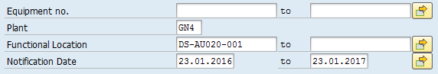

Layout of the report screen should be as follows

- Here user should be given an option to select the Layout of the report which means if the user wants to see only Notification and Long text there should be an option.
- User should be provided an option to download the report from SAP in to Excel spreadsheet.
- User Should be provided to search text string in the SAP report output.
- User Should be able to create a report Layout Variant.

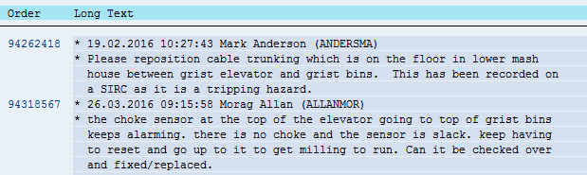

The Selection screen for ZI04 report should be as follows.

- Here Plant and Functional Location field should be made mandatory.
- In the Selection screen user should be able to execute the report with a Layout variant against it.

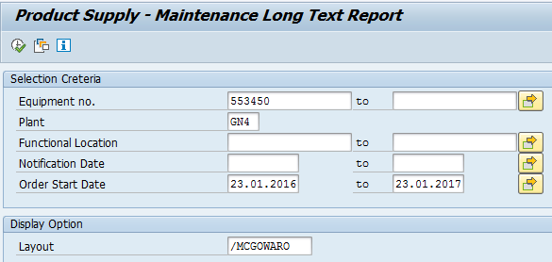

Layout of the report screen should be as follows

- Here user should be given an option to select the Layout of the report which means if the user wants to see only Notification and Long text there should be an option.
- User should be provided an option to download the report from SAP in to Excel spreadsheet.
- User Should be provided to search text string in the SAP report output.
- User Should be able to create a report Layout Variant.

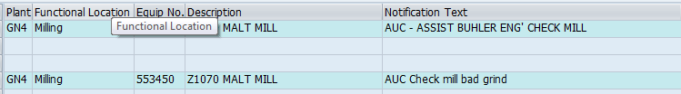
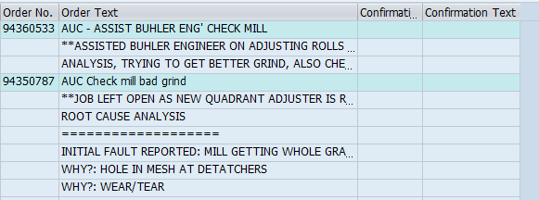

Logic/Flow
- Fetch Long text data based on equipment number, Plant, and notification date or Order Start date.
- Fetch Long text data based on Functional Location, Plant, Notification date, Order start date.

Table Join Logic

For ZI03 please please refer the following table join logic:

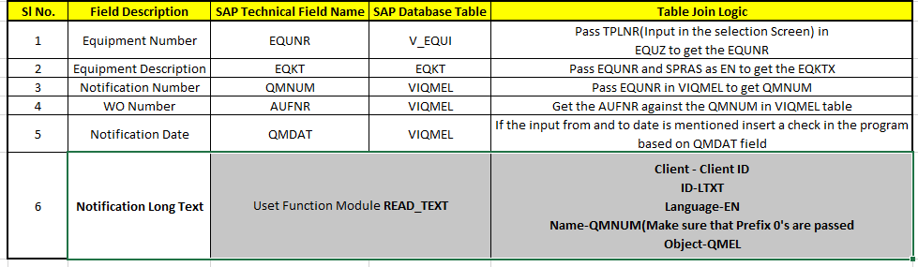

For ZI04 report please refer the following table join logic:

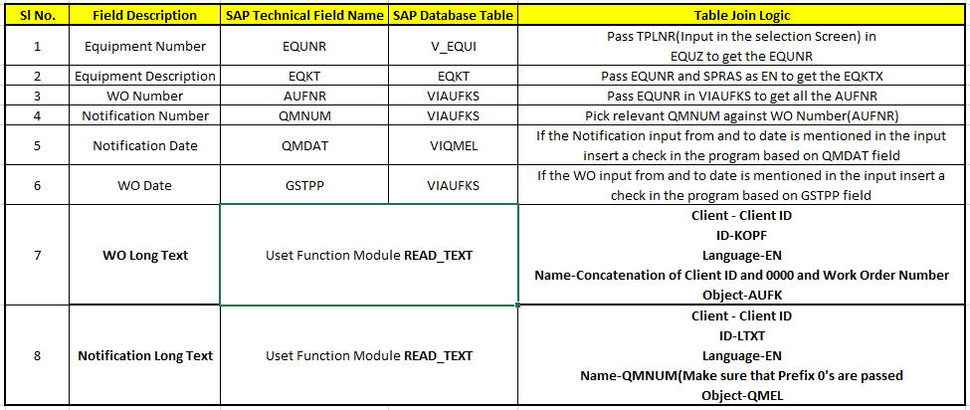

Messages
[Mention if you need and error or information messages for some exceptions]

Message ID | Text | Notes

Security and Authorization
[Mention if any custom authorization or standard authorization need to be checked]

Existing Sample Enhancements
- Program Name:
- Menu / Transaction:
- Related Transactions:

Processing and Operational Considerations

Performance

NA

Batch Requirements

NA

Other

NA

Change Management Requirements

NA

Testing Requirements

Selection Scenarios,

Key Business Test Conditions

ID | Condition | Expected results | Cycle Ref.
1
2
3

Technical Test Conditions

ID | Condition | Expected results | Cycle Ref.
1
2

Risk and Controls Test Conditions

ID | Condition | Expected results | Cycle Ref.

Additional supporting / reference documentation

Data Impact

No data is impacted from this report.

Pre-requisites for ‘Reusability’
[Provide details of pre-requisites for making this object reusable. There could be various dependent factors like master data, configuration, typical industry specific scenario etc.]

